**Your Life is Important, Your Country’s GDP As Well Apparently…**

**How Life Expectancy and GDP are closely correlated?**

It can be very hard to answer that question. However, the different figures will be making it easier and clearer for readers to understand the results or to judge by themselves.

_______________________________________________________________________________________

**Diallo Sibaghatallah**

Thursday 13/02/2020 16:41, GMT+10, Eastern Australia

**The data**

The **data** used for this research has been nicely provided by the **World Health Organization** and the **World Bank**. Thanks to their data collected among **6 different countries** we will see how *surprising the findings are*. ***Is there any link between both?*** The research will answer that NO, there is NO close relation and you will be able to argue the viewpoint exposed here at the bottom of this page. Look at the visualisations first and try to understand it or figure out what is really going on before reading the explanatory paragraphs.

The **data is organized per country per year, from 2000 to 2015**. **Life expectancy and GDP** are displayed for each year. Having such a big file with tons of information requires the use of a system in order to organize the data and to transform present it in a more understandable way.

Python has been chosen as a program to read the data and show through graphs, figures and more elaborated shapes, the results of the research.

Example:

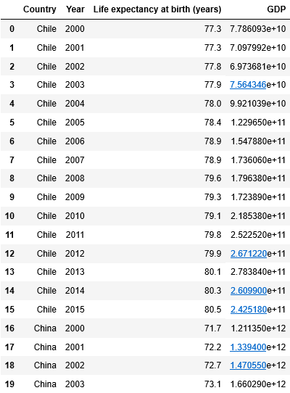

**Definitions**

**What is GDP:**

* Definition from the renown IMF(International Monetary Fund):[“stands for gross domestic product” and “GDP measures the monetary value of final goods and services—that is, those that are bought by the final user—produced in a country in a given period of time (say a quarter or a year). It counts all of the output generated within the borders of a country. GDP is composed of goods and services produced for sale in the market and also includes some nonmarket production, such as defense or education services provided by the government.](https://www.imf.org/external/pubs/ft/fandd/basics/gdp.htm)”

**What is Life Expectancy:**

* Definition from the renown INSEE (National Institute of Statistics and Economic Studies): [“Healthy life expectancy is the average life in good health - that is to say without irreversible limitation of activity in daily life or incapacities - of a fictitious generation subject to the conditions of mortality and morbidity prevailing that year. It characterizes mortality and morbidity regardless of the age structure.”](https://www.insee.fr/en/metadonnees/definition/c2017)

See, How this bar chart compares average GDP in trillions US dollars per country:

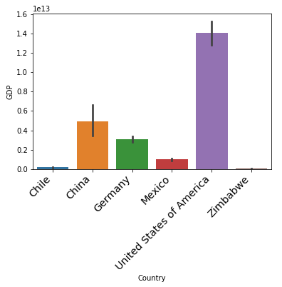

The **GDP of the United States is clearly the biggest** being almost three times bigger than the Chinese one at the second position. Germany’s GDP is lower than China’s, but more than double of Mexico’s GDP. **Chile and** **Zimbabwe are showing GDPs closest to zero**. *Chile's GDP still doubles up the Zimbabwe’s one.*

This bar chart is the figure of the huge differences between GDPs.

We will see if it has correlations with life expectancy...

See, How this bar chart compares average life expectancy in years, called LEABY from now on:

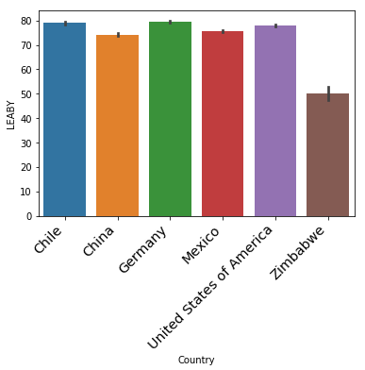

Here, **only Zimbabwe shows a clear difference in life expectancy** when all other countries are harder to differentiate. This life expectancy chart shows that Zimbabwe’s life expectancy is one third lower compared to other countries'.

When we have **huge differences in GDPs**, we **notice here that there are no differences in life expectancy** that we can correlate to GDP levels. The only **exception** has come from **Zimbabwe** showing **lower levels in both GDP and life expectancy.**

*If there were a clear correlation between life expectancy and GDP Chile which was showing an almost “null” GDP figure would have a significantly lower level in life expectancy.*

Can we conclude from this point that there is NO Correlation between life expectancy and GDP?

Let’s see through the next figures what we observed in our research...

See, How is the LEABY distribution per country:

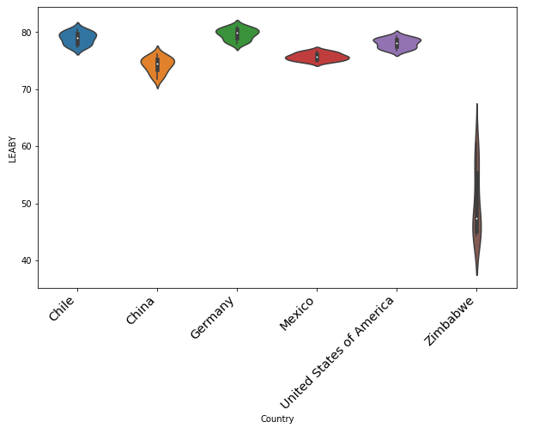

**The distribution gives us another perspective** and we can clearly see that countries like **Chile, Germany and the United States which had significant different levels of GDP** are here having the same or very close distribution figures. On the other hand **some countries are showing deeper information in their life expectancy, like Mexico which has had before in the bar chart the same life expectancy level compared to China**. Here, we can see that Mexico's distribution is around the same age when in China it starts at a lower level, around 70 years old to reach the same point as Mexico’s. **Isn’t this showing more than we forgot an important figure in this study, which is the number of inhabitants per country**. *China has the largest population in the world, isn’t a sign that it is not linked to the GDP?*

Lastly, **Zimbabwe’s life expectancy** throughout this distribution chart **provides us with more information**. We can see now that **it spreads out from levels just under 40 years old to just under 70 years old**. The biggest part, representing most people being between 40 and 50 years old. We all know that **Zimbabwe had for a long time some political issues and have been under strong  United States economic sanctions followed by all other western countries.** *Does this mean here that life expectancy is correlated to GDP?* *Not sure, we see more the effect of poverty at his maximum level due to some political influences because it would be then the same for Chile if the logic was true. Chile, as we have seen, is showing one of the best life expectancy.*

*All this data and different charts representing the same numbers in different ways tell us how much more information we need before concluding*. **For example:** **what is the quality of the food supplied to the population? What is the agricultural system?** Chile is at the same level of life expectancy with the biggest GDP countries like Germany and the United States. But, Chile’s GDP is just as big as Zimbabwe’s even if it looks like it is double (almost double of zero).

**The data is very little in this research.**

**Another question** consequence of those observations is: **What is affecting GDP levels? The Zimbabwe case involves Trades level with other countries.** The capacity to commerce. *Or, maybe Chile has enough food for it’s population which is not as big as Chinese one (so manageable) and politically decide to export only when excess capacity is reached and their trade balance is not showing a huge number???* **We can emit many hypotheses that can be tested. We can say that we have for the moment no evidence of correlation between life expectancy and GDP levels.**

See, How this bar chart compares GDP per countries from 2000 to 2015:

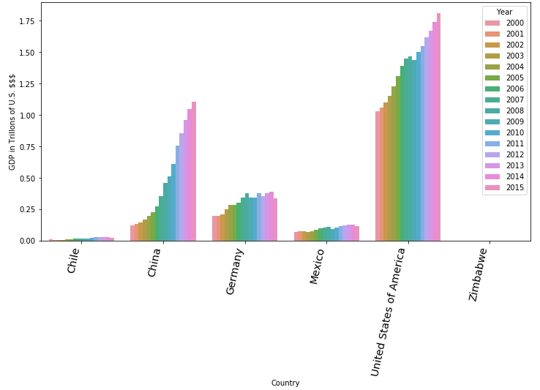

We don’t get much more information here , but **we can definitely say that China and the United States have seen their GDP rise exponentially from 2000 to 2015** when other countries in the study have only slightly risen or stagnated.

See, How this bar chart compares LEABY per countries from 2000 to 2015:

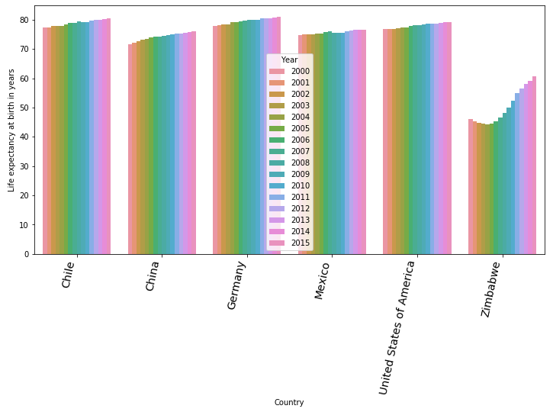

Life expectancy is also very similar to the one we have seen in  the bar chart. **The particularly is that we can see that Chinese life expectancy is regularly rising from 2000 to 2015 and that Zimbabwe’s was declining from 2000 to 2005** and have thereafter risen exponentially for the next 10 years.

See, How those scatter grid graphs shows GDP vs LEABY per country throughout the years:

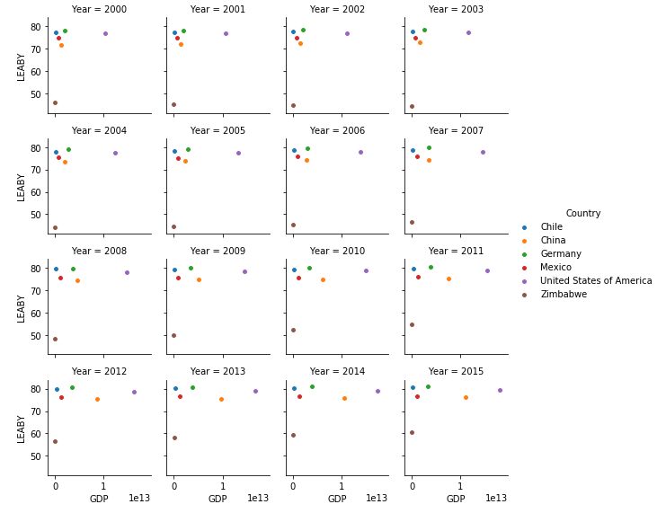

**Shall we conclude now?**

This scatter graph having the GDP’s on the x-axis and life expectancy on the y-axis **is clearly showing that when life expectancy is not changing much for all countries from 2000 to 2015**, we see only China and the United States GDPs significantly evolving in the upside from 2009 for the United States and later from 2012 for China.

See, How those line grid graphs map LEABY by country:

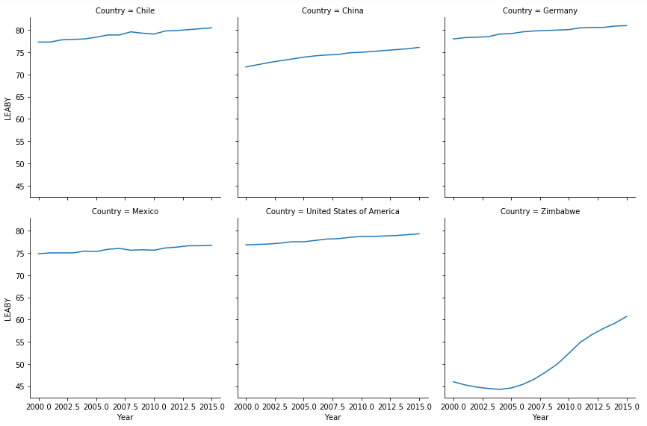

**Life expectancy is growing**. From **Zimbabwe it is exponentially growing even if it stays the lowest.** *We didn’t notice in our data and the charts of life expectancy exponential increase in GDP for Zimbabwe.*

See, How those line grid graphs map LEABY by country:

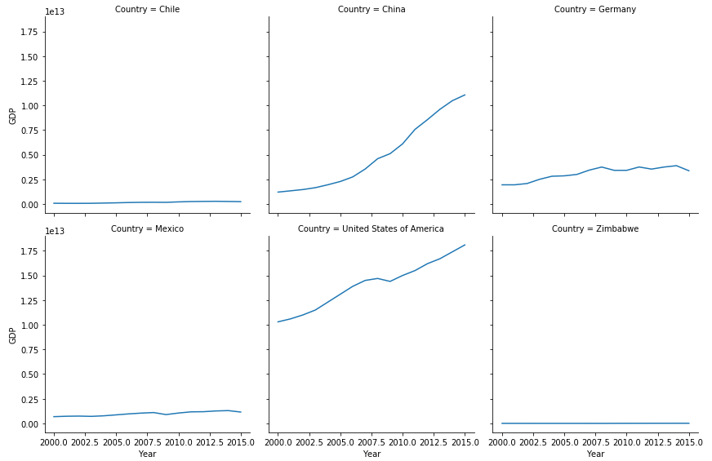

**This grid chart for GDPs shows significant changes for China and the United States**. We haven’t noticed any significant change in our data about their life expectancy.

**We can now draw a conclusion...**

**CONCLUSION**

**This grids graphs confirm our previous finding about the impossibility to correlate life expectancy and GDP**.

More other factors are needed, but, between those two, there are no correlation.

**The data that we have in our research is too limited**.

*We need to have some other correlation like the GDP compared to trade balance, the GDP compared to population number, the life expectancy compared to population number, life expectancy compared to international political sanctions...and more like the agriculture, the population food supply...etc...*

**There is no correlation between life expectancy and GDP.**